Setting Up BroadBand Connection Under Windows® XP for
DSL TURBO 900E Users
~~~~~~~~~~~~~~~~~~~~~~~~~~~~~~~~~~~~~~~~~~~~~~~~~~~
Important Notice!
The WinPoET® Installation CD is no longer required once user’s has updated their operating system to Windows® XP.
~~~~~~~~~~~~~~~~~~~~~~~~~~~~~~~~~~~~~~~~~~~~~~~~~~~~~~~~~~~

Below are the steps to configure your Windows® XP to support BroadBand Connection :

1) Click Start > All Programs > Accessories > Communications > New Connection Wizard
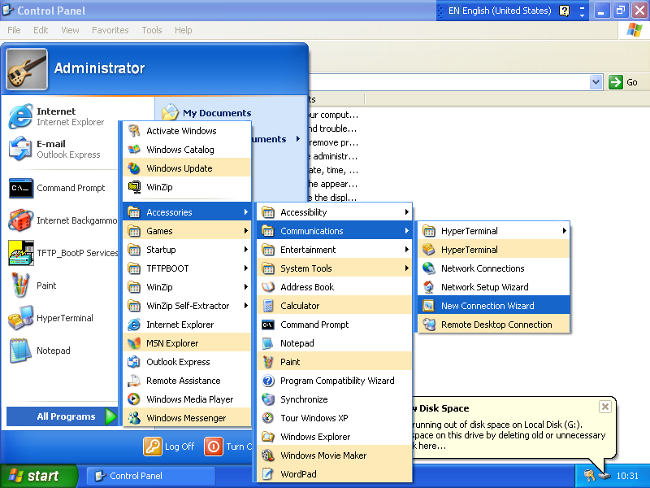

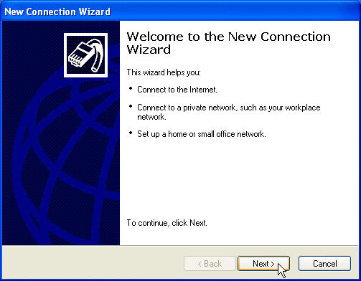
2) Click Next.
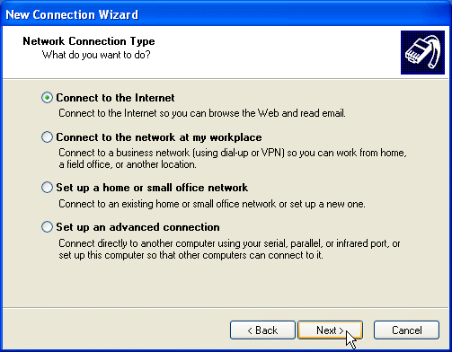
3) Click Next.

4) Select “Set up my Connection manually” and click Next.
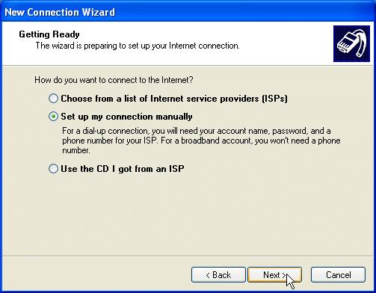

5) Select “ Connect using a broadband…” and click Next.
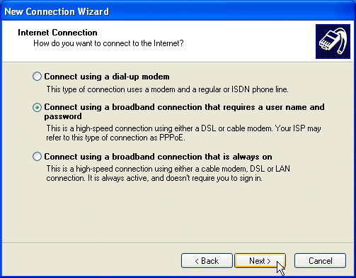
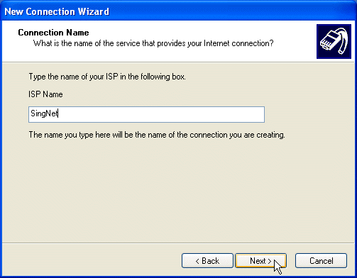
6) Enter the Dial-Up Connection name you desired. Example shown is “SingNet”. Click Next.

7) For the account information, enter your username with “@singnet” for Singnet BroadBand users. Key in your password. Click Next when you are done.
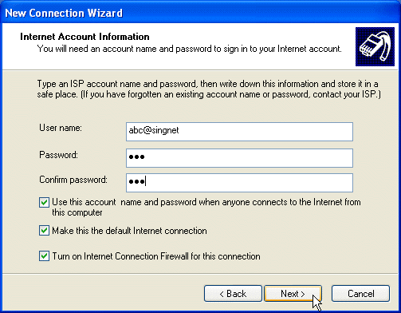

8) Check the box “Add a shortcut…”. Click Finish.
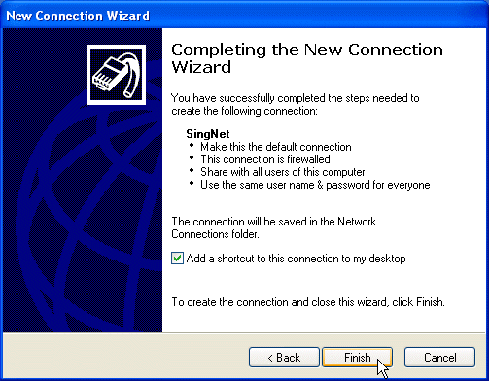


9) You should see the dial-up connection generated on your desktop. Double-click on it.

10) Click on Properties.
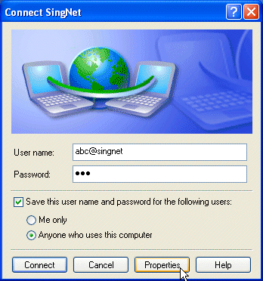

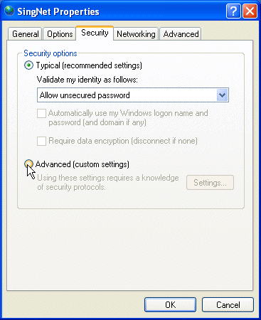
11) Select Security Tab. Select “Advanced(custom settings). Click OK.

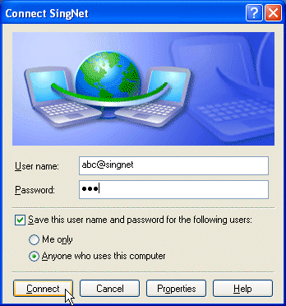
12) Enter your password and click Connect.

13) You should see SingNet is Now Connected. Double-Click on your Internet Explorer® or Netscape® to begin surfing.

