Agenda

8:30 -9:30 Functional Overview & Architecture

9:30 -10:00 Installation

10:00-10:15 Break

10:15-11:30 Installation, Configuration and GUI’s

11:30 – 12:30 Lunch

12:30 - Actual installation

The VST Team

Marketing

Kurt Merriweather Product Manager
Louise Ledeen Marketing Manager

Engineering

Ron Jacoby Principal Engineer
Ashok Yerneni Engineering Manager
Rick Reed Technical Lead

Total 5 core engineers and 4 Q&A engineers

Applied Engineering

Mike Moskowitz Manager Applied Engineering
Hilmi Ortadeveci Applied Engineer

VST Functional Overview & Architecture

- The following topics will be discussed in this module

Functional Overview

What is VST and where can it be used for

Architecture

Overview of the design goals, architecure and the
VST modules

Units

Units can be seen as virtuel VTR heads.
VST uses units to control Media Ports such as the DIVO.

Functional Overview

- VST is designed to transform the Origin servers
into frame accurate and broadcast-quality video servers

- VST leverages the scaleabilty of the SGI Origin servers, the video I/O boards and the digital media libraries

- We do the low-level IRIX and VL programming the developers embed VST in their end user applications

- It’s ment to give SGI developers a competetive advantage by enabling them to create very scaleable media and format indepent video server applications

- VST supports broadcast automations systems such as
Louth, making it an ideal platform to be used in
broadcast environments

- VST can be used to build the following applications

NVOD
time delay
VTR replacement
add insertion
store and forward
new playout

VST Workflow

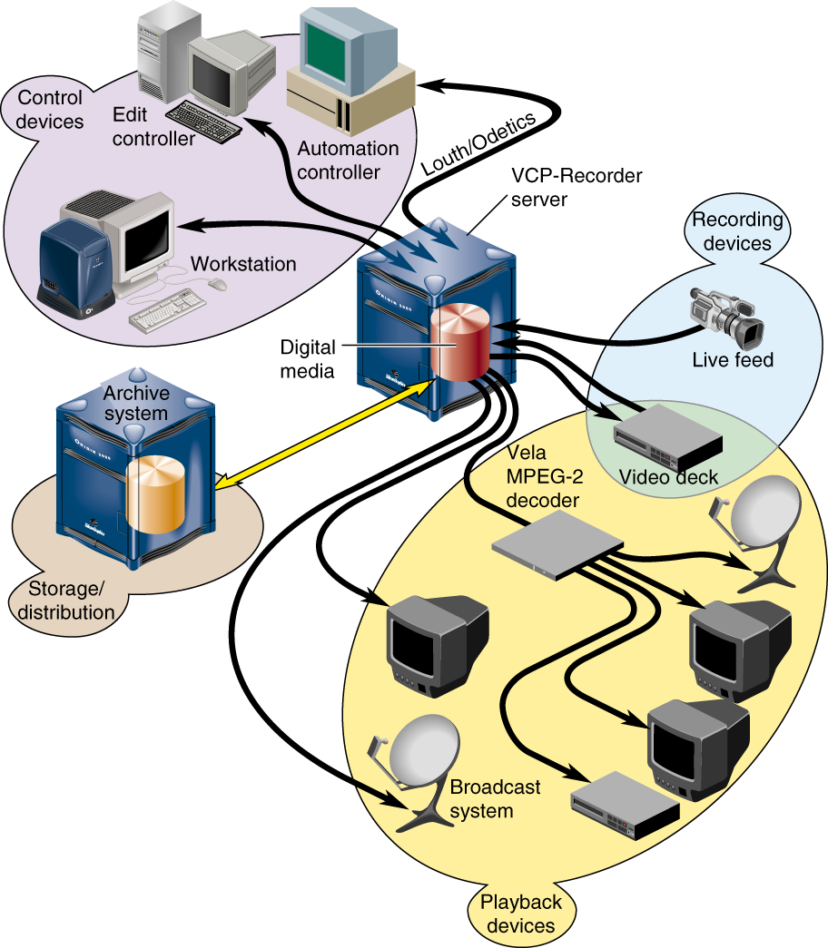

VST Workflow

Digital Media (Clips) are brought into the server by

recording
copying clips
retrieving it from archive

the VST-server van be controlled by

an application based upon MVCP (the VST-gui’s)
broadcast automation systems such as Louth, Odetics
Sony RS-422 protocol

to play out the clips to

broadcast system
a VTR
monitor
MPEG-2 decoder
stored on an archive system

Design Goals

- Development platform

designed to be embedded in application
engine, not a UI

- Audio/Video record/playout platform

acquisition, distribution, play-to-air
not a full-featured editing tool

- Flexible, modular logic

no embedded application logic
plug-in modules

- Media independent

media-format independent
media-device independent

- Performance

real-time, frame-accurate control
configurable for low- and high-bandwidth
efficient data and control flow

- Native archive interoperability

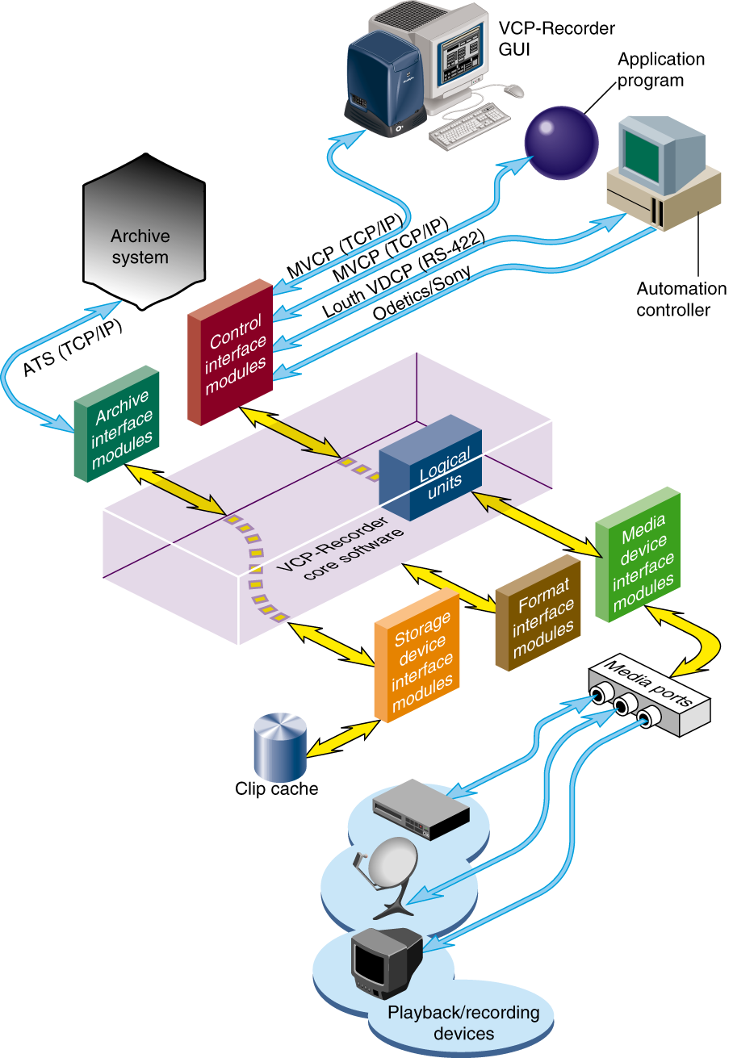
Software Overview

Overview Software Components

- Core Software (vvtr)

provides the basic VST functionality

- Control Interface Modules

device-depending code to support control protocols (eg. Louth)

- Media Interfaces Modules

device-depending code to support media ports (e.g., DIVO)

- Format Interface Modules

format-dependent code to support different media types

- Storage Interface Modules

provides access to storage systems

- Archive Interface Modules

provides native support to store, query and retrieve from archives

Core Software (vvtr)

- The core software provides the basic VST functionality for recording and playback

- It utilizes IRIX as well as portions of the SGI Digital Media Libraries

- The core software provides the following functionality

unit management, which links one or more external control
protocol modules (such as Louth) to the media ports

configuration management, which automatically configures the
VST software according to the hardware capabilities of the system
on which it runs

clip cache management, which maintains persistent information about the media that is either stored in the clip cache or is in the process of being transferred into or out of it

archive management, which manages the transferring of assets into and out of an archive system

- Other provided utilities include

locking
logging
threading

- The core library supports external DSO’s (modules) which contain specific code for external entities

- When VST is started it loads and initializes all external modules which are installed

Clip Cache

- Digital media data that VST processes for playout and recording is stored in one or more clip caches

- Each unit of data that is stored in a clip cache is called
a clip

- Clips can be added to the cache by

using VST to record the clip
recording clips on an other VST-server and adding them to the cache
transferring clips from a SC archive system

Modules

Control Interface Module

- These modules translate to and from external control protocols

- The control interface modules allow various automation controllers and digital media applications to control VST

- The following control interface modules are provided

Louth VDCP
Sony RS-422
Odetics
MVCP

Louth VDCP

- Louth Video Disk Communications Protocol defined by Louth Automation provides control of SVT over

RS-232
RS-422
TCP/IP

- The VST Louth interface module supports back-to-back playout, recording and archive management

Sony RS-422

- The Sony protocol is the standard for controlling VTRs

- The Sony RS-422 VTR protocol is also called 9-pin or P2

- SVT supports this protocol through a VTR deck-emulation mode that includes frame-accurate insert editing and variable-speed shuttle

- The Sony protocol is not fully implemented

Odetics

- The Odetics protocol is a Video Disk Control Protocol similar in purpose to the Louth VDCP

- Is built upon the foundation of the legacy of Sony
RS-422

- Shares many commands and features with Sony RS-422

- Odetics adds to the Sony protocol commands specific to Video Disk Recorders, such as back-to-back playout, recording and clip management operations

MVCP

- Multiple-Unit Video Computer Protocol (MVCP) is the native VST control protocol defined by SGI

- This control protocol provides full-featured control of VST through a TCP/IP connection

- This control interface module supports

archive management
multiple-unit control
event monitoring
provides access to advanced features of SGI devices
Storage Device Interface Module

- Storage device interface modules provide access to the
storage systems on which the clip cache resides.

- Currently there is a storage device interface module for the IRIX XFS filesystem

Format Interface Module

- Format interface modules provide handlers for accessing specific digital media storage formats

- VST currently provides format interface modules that support the following

variable-frame format uncompressed, RICE and JPEG
stream-based format MPEG-2 transport and program streams
frame frame DVCPRO Data Interchange Format

Media Device Interface Module

- Media device interface modules provide access to the media ports over which the media is played and recorded

- Each type of I/O port typically has its own media device interface module

- SVT has media device interface modules for the following

DIVO support for DIVO and DIVO-DVC
O2video support for O2 video
vela support for the Vela Quad decoder
dvb-asi support for the DVB-ASI card
diaquest support for Sony RS-422
V-LAN support for V-LAN

Note: The Diaquest and V-LAN are media device
Interface modules which allow VST to control
videotape decks enabling frame-accurate
capture from, and lay-down to videotape decks

- When a developer wants to use a new media device the
SVT-engineering team needs to develop a new media device interface module

Archive Interface Module

- These modules provide the support that is needed locate
a given clip in an archive system and bring it into VST and transfer clips into an archive

- SVT has an SC 2.0 archive interface module which enables VST to retrieve clips from, and store clips in, an archive asset repository

- VST transfers the media to and from an archive system
using the Asset Transfer Service (or ATS)

Units

Logical Playback and Record Units

- Logical units enable media ports to play and record clips

- Each VST unit can be thought of as a logical videotape recorder (VTR) transport that is capable of loading, cueing playing and recording clips using a specific media port
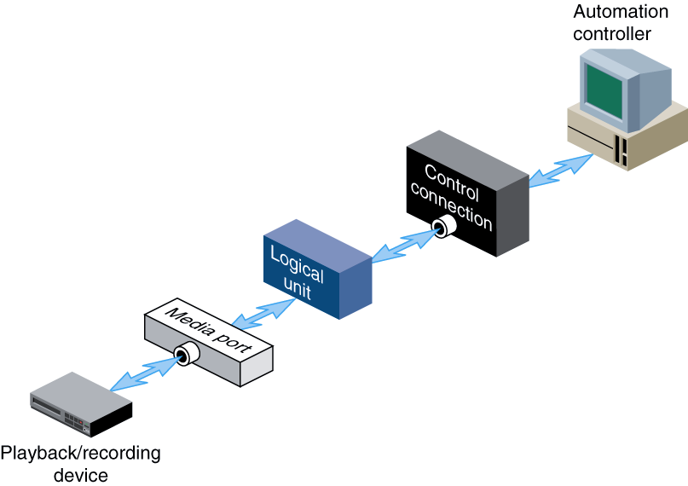

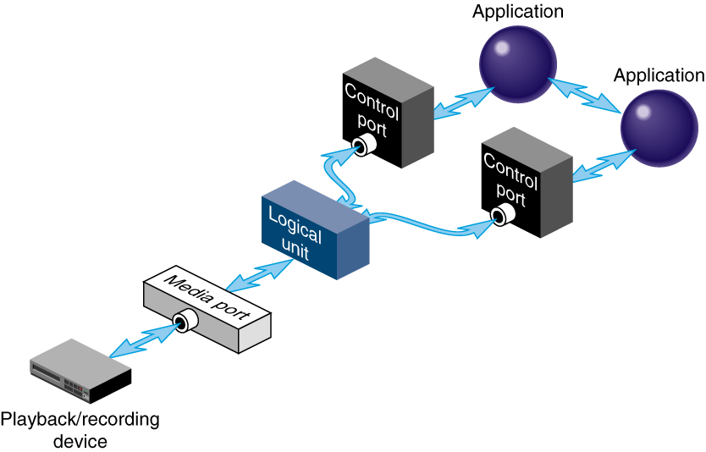
- Logical units are created automatically by VST if the VST GUI or an automation controller is used

- When the MVCP protocol is used an unit can be created with the UADD command or a unit (created by another control connection) can be opended with UOPEN

- There is normally a one-to-one relationship between a control connection to VST and a VST logical unit, and between a logical unit and a media port

- A single unit can also be controlled by multiple control
ports. For example, two tightly integrated applications
might control a single unit, where each application
would have its own control port.

- A media port can also be controlled by multiple logical units. For example, an application with one control connection and two units could be cueing one clip while playing out another, enabling back-to-back playout of clips when allowed by the media format
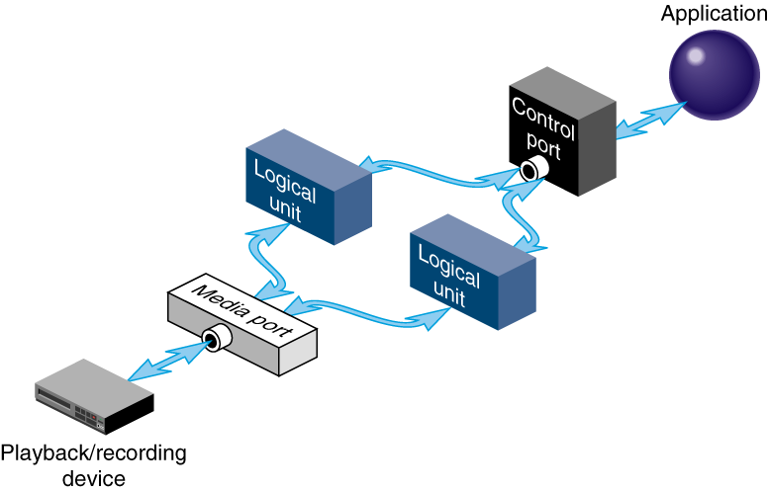

- A media port can have multiple (>2) units connected to it

- In case of a NETWORK media port (e.g., DVB-ASI) each output channel will be a separate unit

Installing VST

- The following topics will ne discussed in the section

Supported Hardware

Overview of the supported server, media and disk storage
hardware

Installing VST SW

Overview of the required SW for the varoius VST configurations. Also an overview of the VST subsystems

Setting up the Clip Cache

Creating the striped XLV is the most important part of the installation. Both real-time and non-real time filesystems will be discussed and configuring GRIO

Supported Hardware

- Origin 2000

- Origin 200

- Onyx2

- O2 workstation

NOTE: O2 is supported for development only!

- Target Platform is O200 with GIGAChannel

- Majority of the testing is done on O200

- Limited testing for O2000 and almost none
for Onyx2

Supported Media I/O Boards

Video Devices

- DIVO XIO-based

- DIVO DVCPRO XIO-based

- Quad MPEG-2 Decoder SCSI-based

- DVB-ASI PCI-based

- O2 Video AV1 (Analog) O2-AV-IO

- O2 Video AV2 (Digital) O2-AV-IO

Audio Devices

- IO6G XIO-based

use the IO6G of a Onyx2 in a O2000

- RAD PCI-based

AES 2 digital stereo pairs
ADAT 8 optical channels (24 bit)

Origin 200

1-4 Digital Video Option boards

XT-DIVO or XT-DIVO-DVC

2P with GIGAChannel

- 1-8 Digital Video Option boards

XT-DIVO or XT-DIVO-DVC

2P with GIGAChannel

- 1-3 Vela MPEG2 Quad decoders per SCSI bus

- 1-3 DVB boards

ViewGraphics MediaPump MP 403 DVB-ASI (Input/Output)
DVB-ASI playout only

Origin 2000 & Onyx2

1-8 Digital Video Option

XT-DIVO or XT-DIVO-DVC

- 1-3 Vela MPEG2 4-port SCSI based decoders per bus

- Both Configs are not fully-qualified for production use

- Developer is responsible for system intergration testing

- The DVB-ASI card has never been tested on an

Origin 2000

O2

- AV1 (Analog Video Option)

- AV2 (Digital Video Option)

- 1 Vela MPEG2 4-port SCSI decoder

- DEVELOPMENT ONLY!

- Not qualified for production

- Uncompressed currently not supported on O2

I/O SLOTS

- Origin 2000

Node | XIO | PCI
1 | 4 | 2 ½
2 | 10 | 2 ½

Note: If the PCI shoebox isn’t used an additional
XIO slot will be available

- Origin 200

Tower(s) | XBOX | XIO | PCI
1 | 0 | 0 | 3
1 | 1 | 5 | 6 ½
2 | 1 | 5 | 9 ½
2 | 2 | 10 | 12 +2 x ½

- Note: ½ PCI slot means half-length PCI slot

1 PCI slot means full-length PCI slot

- The DVB-ASI board needs full-length PCI slot

Disk Storage Options

- For O200/O2000

Ciprico 7000 RAID 3 Fibre Channel : ~44 MB/sec

Ciprico FibreStore (JBOD) : >50 MB/sec

Clariion RAID 3 Fibre Channel : ~38 MB/sec

Clariion JBOD FibreChannel : ??

4 striped UltraSCSI drives : ~30 MB/sec

- For O2

UltraSCSI option drive : ~ 7.0 MB/s

- Above rate’s are approximates and depend on the
stripe unit size which will be used

- Ciprico 7000 FC disk arrays are only ones used for testing

Bandwidth Considerations

- 8-bit 601 uncompressed : 21 MB/sec

- RICE (DIVO only) : 11 MB/sec

- DVCPRO : 4 MB/sec

- JPEG : 1 MB/sec – 8 MB/sec

- MPEG-2 : 3 Mb/sec – 8 Mb/sec

- Above rate’s are approximates

- RICE is a lossless coding algorithm thus few reasons to
use uncompressed

- Uncompressed currently not supported on O2

Required Software

- READ RELNOTES FOR UP-TO-DATE INFO!

- Overview of required software for the current VST
release 1.1

- Origin 200, Origin 2000 & Onyx2

IRIX 6.4.1

Recommended & Required patches Dec 1998

Patches included on the VST CDROM

Optional: DIVO SW from VST CDROM
MediaPump SW from VST CDROM

- O2

IRIX 6.5

- GRIO license is required if grio is used with
more then 4 simultaneous streams

- Plex license if plexing is used

Installing VST SW

- Install required patches, check relnotes for up-to-date
info about the required patches

Patches consist of

Recommended Required patches Dec 1998 or later
VST config specific patches from the VST CDROM

- Install eoe.sw.xlv

- Install eoe.sw.xfsrt

- Following VST subsystems are selected for installation

by default

vcp_recorder_eoe.man.base [d]

vcp_recorder_eoe.man.relnotes [d]

vcp_recorder_eoe.man.tools [d]

vcp_recorder_eoe.sw.base [d]

vcp_recorder_eoe.sw.tools [d]

- Make sure to install the appropriate VST subsystems

required for media device support or other functionality

Installation of specific VST configs

- Origin 200/2000 & Onyx2 with DIVO-DVC

IRIX 6.4
Origin 200/2000 Required Patches for IRIX 6.4 (12/1/98 or later)
DIVO Video Execution Environment, 1.3 for IRIX 6.4
Patch 3249 (6.4 grio rollup #3; add FC support)
Patch 3249 is only required only for a real-time fs Clip Cache
Patch 2505 (6.4 PCI Audio Expansion Card Support and audio fixes)
Patch 3416 (tserialio update for 6.4 (driver and user library))
Patch 3146 (dmedia Audio encode/decode and divo 1.3 on 6.4)

vcp_recorder_eoe.sw.divo (for VST DIVO media port support)

- Check following table for subsystems needed
for specific components such as:

Louth
Sony RS-422 control
VST enhanced vtrftpd
Etc.

VST subsystem Description

vcp_recorder_eoe.books.AdminGuide Installation and Administration
Guide

vcp_recorder_eoe.books.DevelGuide Developers Guide

vcp_recorder_eoe.books.AdminGuideHTML HTML Installation
and Admin Guide

vcp_recorder_eoe.books.DevelGuideHTML HTML Developers Guide

vcp_recorder_eoe.man Man pages

vcp_recorder_eoe.man.base Base man pages

vcp_recorder_eoe.man.ftpd Enhanced FTP daemon man pages

vcp_recorder_eoe.man.relnotes Release notes

vcp_recorder_eoe.man.tools Base applications ma n pages

vcp_recorder_eoe.sw.base Base software

vcp_recorder_eoe.sw.diaquest Diaquest deck-control module

vcp_recorder_eoe.sw.divo DIVO video module

vcp_recorder_eoe.sw.dvb-vg ViewGraphics DVB/MPEG module

vcp_recorder_eoe.sw.failsafe Failsafe Configuration Files

vcp_recorder_eoe.sw.fsmon File System Import Monitor
VST subsystem Description

vcp_recorder_eoe.sw.ftpd Enhanced FTP daemon

vcp_recorder_eoe.sw.horita Horita TC input module

vcp_recorder_eoe.sw.little-red Miranda Little Red TC input module

vcp_recorder_eoe.sw.louth Louth VDCP control module

vcp_recorder_eoe.sw.mpeg MPEG2 tools

vcp_recorder_eoe.sw.o2video O2Video module

vcp_recorder_eoe.sw.sony-odetics Sony/Odetics control module

vcp_recorder_eoe.sw.studiocentral StudioCentral archive interface

vcp_recorder_eoe.sw.tools Base applications

vcp_recorder_eoe.sw.vela Vela SCSI MPEG2- decoder module

vcp_recorder_eoe.sw.vlan VLAN deck-control modul

- The /usr/vtr directories

bin/* utilities and VSTexecutable, vvtr

clips/* Clip Cache (can be symlink)

config/* Configuration files

data/* Files under this directory are static data or image files
used by various VSK components

images/* The directory under which still images are created
when the MVCP CIMG command is executed

index/* Clip indices (vframe formats, RICE, Uncomressed, JPEG)

install/ Files that are used during the installation

lib32/ Core and shared libraries

lib32/modules/ External interface device/control/format modules.

Setting up the Clip Cache

- Use of a real-time file is system strongly recommended

VST is designed to be used with real-time filesystems
enables the use of GRIO (disk I/O bandwith management)
enable features such as priority I/O for record/playout channels

- When using RAID, use RAID 3 only (big I/O sizes)

- Use Ciprico FC RAID/JBOD disk arrays

- Disk space requirement guidelines

Format | Rate  MB/s | 1 min  GB | 1 hour  GB
Uncomp | 21 | 1.26 | 75.6
RICE | 11 | 0.60 | 36.0
DVCPRO | 4 | 0.24 | 14.4

- Striping guidelines for determining the stripe-unit

choice between:
disk bandwidth/memory consumption
latency

USCSI disks 256KB-512KB

Fibre Channel JBOD 256KB-512KB

Fibre Channel 4+1 RAID 1MB-2MB

Fibre Channel 8+1 RAID 2MB-4MB
- The /usr/vtr/clips directory is the hard coded default
clip cache directory for VST

- The /usr/vtr/clips directory is the VST relative root
root directory

/usr/vtr/clips/clip.rice is clip.rice for VST
/usr/vtr/clips/fc/clip.dif is fc/clip.dif for VST

- If multiple clip cache’s are required create
subdirs under /usr/vtr/clips

/usr/vtr/clips/rice
/usr/vtr/clips/rice-625
/usr/vtr/clips/mpeg

Don’t forget to create the required index directory

/usr/vtr/index/rice
/usr/vtr/index/rice-625
/usr/vtr/index/mpeg

- Use of symlinks is supported

Non-Real Time Clip Cache

- Options for setting up a non-real time Clip Cache

one option disk
several striped disks
one RAID 3 disk array
striped RAID 3 disk arrays (same as several striped disks)

- Memory page sizes:

32 bit kernels = 4 KB (O2)
64 bit kernels = 16 KB (Origin servers)

- The desired I/O size must be a multiple of the greater of the memory page size or filesystem block size

on a O200 that means that the I/O size needs to be a multiple of 16 KB

when 256KB-512KB stripe-unit sizes are used
this requirement will always be met

4 * 512 KB = 2048KB / 16KB = 128 valid I/O size
4 * 450 KB = 1800KB / 16KB = 112.5 invalid I/O size

- The memory usage is determined by the I/O size of the
clip cache

- Always specify a blocksize of 16 KB when a filesystem
is created to be used as clip cache
- Example of creating a 3-way striped XLV using
USCSI option disks

xlv_make
xlv_make> vol clips
clips
xlv_make> data
clips.data
xlv_make> plex
clips.data.0
xlv_make> ve -stripe_unit 1024 dks2d1s7 dks2d2s7 dks2d3s7
clips.data.0.0
xlv_make> end
Object specification completed
xlv_make> exit
Newly created objects will be written to disk.
Is this what you want?(yes)
Invoking xlv_assemble

NOTE: the stripe_unit is in disk blocks, 1 block = 512 bytes

- Next step is creating a filesystem

mkfs –b size=16k /dev/xlv/striped

- Mount XLV volume on /usr/vtr/clips

- Symlinks are allowed

- Put corresponding entry in /etc/fstab

- Instruct VST to use a I/O size equal to stripe size
of the created XLV

using the stripe unit used in the above example the I/O needs to be:

512 KB * 3 disks = 1536 KB

create the /usr/vtr/config/device-defaults/vtrfsinfo.conf file
add /dev/xlv/striped 1536K 1536K

See “Configuring VST” for detailed info on vtrfsinfo.conf

- Memory usage per channel is 3 * I/O size. Double this
When seamless back-to-back is required

- In case of a single RAID 3 array

create a filesystem with a 16 KB blocksize
create the vtrfsinfo.conf file

- Treat a striped RAID XLV the same way as striped disks

- In case of a single disk create a a filesystem with a
16KB blocksize

- Modify the maxdmasz if the required I/O size is larger then 4 MB

see configuring SVT

Real-Time Clip Cache

- Real-Time XLV guidelines

data subvolume should be 200 MB
stripe unit between 256KB-512KB
try to put only real-time volumes on controller
when using RAID, the use of two internal disks to plex the
data subvolume is advisable (single-point-failure)

- Options for setting up a non-real time Clip Cache

several striped disks
one RAID 3 disk array
striped RAID 3 disk arrays (same as several striped)

seperate option disk is required for the data subvolume
or use the system disk, this requires repartion and reinstallation of OS

- The desired I/O size must be an multiple of the
greaterof the memory page size or fs block size

on a O200 that means that the I/O size needs to be a multiple of 16 KB

when 256KB-512KB stripe-unit sizes are used
this requirement will always be met

4 * 512 KB = 2048KB / 16KB = 128 valid I/O size
4 * 450 KB = 1800KB / 16KB = 112.5 invalid I/O size

- Example of creating a XLV for a real-time filesystem
which will be striped across 2 RAID units

xlv_make
xlv_make> vol rt_clips
rt_clips
xlv_make> data
rt_clips.data
xlv_make> plex
rt_clips.data.0
xlv_make> ve dks0d2s7
rt_clips.data.0.0
xlv_make> rt
rt_clips.rt
xlv_make> plex
rt_clips.rt.0
xlv_make> ve -stripe_unit 4096 dks2d1s7 dks2d2s7
rt_clips.rt.0.0
xlv_make> end
Object specification completed
xlv_make> exit
Newly created objects will be written to disk.
Is this what you want?(yes)

NOTE: the stripe_unit is in disk blocks, 1 block = 512 bytes

the extentsize needs to be equal to the stripe size
for this example that is

4096 * 512 * 2 = 4194304 bytes = 4096 KB = 4 MB

In this example the memory usage will be 4 MB * 3 = 12 MB

- Create a real-time filesystem

use a blocksize of 16 KB (always!)
use a extensize equal to the stripe size

for the above example this would be

mkfs –b size=16k –r extsize=4m /dev/xlv/rt_clips

- Mount fs on /usr/vtr/clips

- Add a /etc/fstab entry

- Configuration of the vtrfsinfo.conf is not needed, VST
will automatically us the correct I/O size

- If a different I/O size is required, don’t recreate the fs. Just add an entry in the vtrfsinfo.conf with the required
I/O size

- Modify the maxdmasz if the required I/O size is larger then 4 MB

see configuring SVT

Configuring GRIO

Striped XLV

- First step: /etc/init.d/grio start

ggd will report unkown disks

- When there are any unkown disks, run grio_bandwidth
to determine OPS for desired I/O size

- In case of striped disks use stripe unit as I/O size

Run xlv_assemble to determine the stripe unit of the disks

xlv_assemble: Checking for Disk Plexing Option ... done
…
start=0, end=71116799, (stripe)grp_size=2, stripe_unit_size=1024
/dev/dsk/dks0d6s7 (35558944 blks)
/dev/dsk/dks0d5s7 (35558944 blks)
…

In this example the stripe_unit is 1024 DISK BLOCKS = 512KB

grio_bandwidth –d /dev/dsk/dks0d6s7 –t 60 –s 524288 -u

-d disk device (use the disk device grio reported as unkown)
-t number of seconds the test is performed (60 sec. is min)
-s I/O size in BYTES
-u update /etc/grio_disks automatically

- Re-run /etc/init.d/grio start, when the striped volume
consists of only 1 type of disk grio will report the
number useable streams (4 without GRIO license)

- If the striped volume consist of several types of
disks grio will report the following unkown disk
Repeat grio_bandwidth for all the disk untill grio
doesn’t report any error messages anymore

Real-time filesystem covering one partion

- If one FC RAID 3 disk array is used the OPS for
the extensize of the real-time fs needs to be determined

Example:

Ciprico 7000 with a real-time filesystem that has a 4 MB extentsize

use xfs_growfs –n /mountpoint to determine extentsize

xfs_growfs -n /usr/vtr/clips
meta-data=/usr/vtr/clips isize=256 agcount=8, agsize=8192 blks
data = bsize=16384 blocks=65536, imaxpct=25
log =internal bsize=16384 blocks=1000
realtime =external bsize=4194304 blocks=8890880, rtextents=34730

The last line reports the extentsize in this case it is 4194304 bytes = 4 MB

1024 * 1024 * 4 = 4194304 bytes = 4096 KB = 4 MB
- Run grio_bandwith, specify extensize as I/O size

grio_bandwith –d /dev/dsk/dks2d1s7 –t 60 –s 4194304

System will reports something similar to this:

Device /hw/module/1/slot/io7/MotherBoard/pci/3/scsi_ctlr/0/target/1/lun/0/disk
with ID “Ciprico Rimfire 7010 03.1”,
using only read ops, provided:
on average: 10 ops of size 4194304 each second
in the worst case: 9 ops of size 4194304 each second

- Use the /hw path obtained from grio_bandwidth to
edit /etc/grio_disks file

REPLACE /hw/module/1/slot/io7/MotherBoard/pci/3/scsi_ctlr/0
4194304 25

REPLACE
/hw/module/1/slot/io7/MotherBoard/pci/3/scsi_ctlr/0/target/1/lun/0/disk
4194304 11

NOTE: Each REPLACE entry should be placed on one line!

- Restart grio, /etc/init.d/grio start

GRIO should report numbers of useable streams

- When several RAID units have been used to create a striped
XLV use the stipe unit as I/O size instead of the extentsize

- When JBOD is used determine the OPS for one
disk and put a REPLACE statement for each disk
in the /etc/grio_disk file

REPLACE /hw/module/1/slot/io3/fibre_channel/pci/1/scsi_ctlr/0 524288 200
REPLACE /hw/module/1/slot/io3/fibre_channel/pci/1/scsi_ctlr/0/target/1/lun/0/disk 524288 25
REPLACE /hw/module/1/slot/io3/fibre_channel/pci/1/scsi_ctlr/0/target/2/lun/0/disk 524288 25
REPLACE /hw/module/1/slot/io3/fibre_channel/pci/1/scsi_ctlr/0/target/3/lun/0/disk 524288 25
REPLACE /hw/module/1/slot/io3/fibre_channel/pci/1/scsi_ctlr/0/target/4/lun/0/disk 524288 25
REPLACE /hw/module/1/slot/io3/fibre_channel/pci/1/scsi_ctlr/0/target/5/lun/0/disk 524288 25
REPLACE /hw/module/1/slot/io3/fibre_channel/pci/1/scsi_ctlr/0/target/6/lun/0/disk 524288 25
REPLACE /hw/module/1/slot/io3/fibre_channel/pci/1/scsi_ctlr/0/target/7/lun/0/disk 524288 25
REPLACE /hw/module/1/slot/io3/fibre_channel/pci/1/scsi_ctlr/0/target/8/lun/0/disk 524288 25

- When GRIO (ggd) is running check the bandwidth
for the configured real-time filesystem

grio -C -d /dev/dsk/dks3d1s7

GRIO information for path of disk device /dev/dsk/dks2d2s7

GRIO information for device:
/hw/module/1/slot/io7/xbox_dualxtown/pci/0/scsi_ctlr/0/target/2/lun/0/disk
opt i/o size: 4194304 bytes
reservations: 1 ops currently reserved (max. per quantum), 10 ops maximum
bandwidth: 36864 kbytes/sec available, 40960 kbytes/sec maximum
GRIO information for device:
/hw/module/1/slot/io7/xbox_dualxtown/pci/0/scsi_ctlr/0
opt i/o size: 4194304 bytes
reservations: 1 ops currently reserved (max. per quantum), 25 ops maximum
bandwidth: 98304 kbytes/sec available, 102400 kbytes/sec

Clip Cache for Uncompressed video

- RICE is lossless coding, thus few reasons to use
uncompressed

- If uncompressed is a requirement the following guidelines will achieve the best performance

- NTSC (525) Uncompressed Clip Cache

Stripe unit of 552 disk blocks = 226 KB

Stripe size of 2260992 bytes for 8 striped disks
Stipe size holds exactly 6 uncompressed 4:2:2 8-bit fields

Stripe size of 1081344 bytes for 4 striped disks
Stipe size holds exactly 3 uncompressed 4:2:2 8-bit fields

- PAL (625) Uncompressed Clip Cache

Stripe unit of 624 disk blocks = 312 KB

Stripe size of 2654208 bytes for 8 striped disks
Stripe size holds exactly 6 uncompressed 4:2:2 8-bit fields

Stripe size of 1327104 bytes for 4 striped disks
Stipe size holds exactly 3 uncompressed 4:2:2 8-bit fields

VST Configuration

- The following topics will be discussed in this module

VST config directory

Overview of the structure of the VST config directory.
All config files will be discussed

Configuration of the optional VST components

Discussion of how to configure components which can be installed optionally

VST config directory

- There are two ways of configuring VST

config files read during startup (static)
via MVCP dynamic

- This part covers the static config files

- All config files are stored in /usr/vtr/config

- The files in this directory will *only* be read at startup (vtrstart)

- Structure of /usr/vtr/config

/usr/vtr/config for general config files

/usr/vtr/config/device-defaults device controls

/usr/vtr/config/system-defaults system controls

- system controls can only be set during startup

- device controls can be set during and after startup

General config files

- These files are used to configure specific components
(e.g., vtrftpd), the vtr deamon and control protocol
devices (e.g., Louth, Sony)

- Files in the /usr/vtr/config directory:

control-in.conf
control-out.conf
ports.conf
studiocentral.conf
vtrd.conf
vtr_ioconfig.conf
vtrfsinfo.conf
vtrftpd.conf

- Not all of the above config files will be created
automatically

The control-in.conf file

This file is used to configure devices which control VST
The currently supported remote devices are those supporting the protocols defined by Sony, Louth and Odetics

- The control-in.conf file has three parts:

Network transmission specification one line per file
Serial port configuration one line per device
Signal configuration one line per device

- sample control-in.conf

mvcp tcp 5250

louth rs422 2 38400 1 1 29.97 3
louth rs232 3 38400 1 2 29.97 3
louth tcp 8777 - - 3 25 3
odetics rs422 4 38400 1 4 29.97 0
sony rs422 5 38400 1 5 29.97 0
p2 rs422 6 38400 1 6 30 0
hsip rs232 8 9600 0 1 29.97

signal 1 DIVO_0
signal 2 DIVO_1
signal 3 DIVO_2
signal 4 DIVO_DVC_4
signal 5 DIVO_3
signal 6 DIVO_DVC_1
- Network transmission specification line

this line is used to configure and enable MVCP

syntax:

protocol_name transmission_medium port_number

only valid line:

mvcp tcp 5250

if tcp port 5250 is in use by another application a different tcp
port number can be used.

this line is required to use MVCP

when this line is missing or a different tcp port number is used
the VST GUI’s won’t work

- Serial Port Configuration Lines

these lines are used to configure the serial controlling devices
such as Sony, Louth and Odetics

syntax

<prot> <comm type> <comm port> <speed> <parity> <video> <rate> <preroll>

example:

sony rs422 4 38400 1 1 29.97 0

a remote device is controling a media port which is associated with
signal 1 using sony protocol and a framerate of 29.97.
in this case it connected to serial port 4 which is to 422 mode,
38400 bps and odd parity. Pre-roll is 0

<prot>

The <prot> field specifies control protocol wich will be used

Valid values are

tcp
sony
p2
odetics
louth
vlan
hsip (Horita) (timecode reader)
littlered (timecode reader)

to use sony/p2/odetics install vcp_recorder_eoe.sw.sony-odetics
to use louth install vcp_recorder_eoe.sw.louth
to use hisp install vcp_recorder_eoe.sw.horita
to use littlered install vcp_recorder_eoe.sw.little-red

Note: P2 is the Panasonic name for the Sony RS-422 protocol

<comm type>

The <comm type> field determines in which mode in the serial port of the server will be controlled

Valid values are

rs232, for a RS-232 control connection.
rs422, for a RS-422 control connection.
<comm port>

The value of <comm port> must be an integer that corresponds to the existing serial port on the server

A value of 1 is not supported. This is the console port

<speed>

The <speed> value specifies the connection speed between the serial port on the server and the controlling device

Valid values are

9600
14400
28800
38400

note: for Sony, P2 and Odetics devices the value is always 38400

<parity>

This field determines the parity of the connection

Valid values are

0 indicating no parity
1 indicating odd parity
2 indicating even parity

odd parity is used by most control protocols
no parity is the setting required for timecode readers

<video>

The <video> value is an arbitrary unique number that corresponds to the signal number associated with a media port

In case of a TC reader this value is the time channel

This means that you can have two serial config lines with the same video number

p2 rs422 6 38400 1 1 30 0
hsip rs232 8 9600 0 1 29.97

A value of 0 is not supported

<rate>

The <rate> value specifies the number of frames per second displayed. Also referred to as framerate

Valid values are

24 for film
25 for the PAL video format
29.97 for NTSC drop-frame video
30 for NTSC non-drop-frame video

<preroll>

This field determines the pre-roll of a issued command.
The pre-roll is only required for Louth and is used to
compensate the latency of the media port.

The pre-roll value depends on the media port

use a value of 3 for Louth -> DIVO
use a value of 5 for Louth -> DIVO-DVC

use a value of 0 for all other protocols

control-out.conf file

this file is used to configure VST as a controlling device.
currently supported outbound control protocols are

Sony RS-422 and VLAN

syntax

<prot> <comm type> <comm port> <speed> <parity>

example

vlan rs422 2 38400 1
sony rs422 3 38400 1

to use vlan install vcp_recorder_eoe.sw.vlan
to use sony install vcp_recorder_eoe.sw.diaquest

<prot>

The <prot> field specifies the control protocol to use

The valid values are

sony
p2
vlan

to use sony install vcp_recorder_eoe.sw.diaquest
to use vlan vcp_recorder_eoe.sw.vlan

<comm type>

The <comm type> field determines in which mode in the serial port of the server will be controlled

Valid values are

rs232, for a RS-232 control connection.
rs422, for a RS-422 control connection.

<comm port>

The value of <comm port> must be an integer that corresponds to the existing serial port on the server

A value of 1 is not supported. This is the console port

<speed>

The <speed> value specifies the connection speed between the serial port on the server and the controlling device

Valid values are

9600
14400
28800
38400

note: for Sony, P2 and Odetics devices this value is always 38400
<parity>

This field determines the parity of the connection

Valid values are

0 indicating no parity
1 indicating odd parity
2 indicating even parity

odd parity is used by most control protocols
no parity is the setting required for timecode readers

The ports.conf file

This file can be used the to map physical port names such as DIVO_0, to logical port names, such as ChA

example

port DIVO_0 ChA “On-Air Channel A”
port DIVO_1 ChB “On-Air Channel B”

vtrstat -p
# Port Type Description
----------------------------------------------------------
1 ChA Video On-Air Channel A
2 ChB Video On-Air Channel B

The vtrd.conf file

This is the configuration file to set options for the SVT core executable vvtr

syntax

name cpu# priority min-retry(ms) max-retry(ms) term-signal command

example

vvtr * * * * TERM “/usr/vtr/bin/vvtr –f2”

normally you don’t edit this unless

some debugging is required (add –f2)
the number of required units > 32 (add –u64)

The vtr_ioconfig.conf file

This file is used to remap the vela logical numbers.
This file has the same functionality as the
/etc/ioconfig.file (see man ioconfig)

This file won’t be created by default.

The vtrfsinfo.conf file

This file is used to set the I/O and alignment size for
non-real time filesystems or change the I/O and alignment size for real-time filesystems

This file needs to be created manually

syntax

device_name I/O_size alignment_size

example

/dev/xlv/striped 4m 4m

device_name

This is the device path for the disk or the XLV volume

Valid device paths are

/dev/dsk/dks2d1s7
/dev/xlv/striped

I/O_size

This is the desired I/O size for the none real-time fs
In case of a striped XLV volume this value should be equal to the stripe size

some valid (integer) values are

4096k
2m

alignment_size

Should always be equal to the I/O_size. Unless the clips
recorded will be transferred to a system with a different alignment size.

Some valid (integer) values are

1m
1536k

note: if an I/O size larger then 4 MB will be used modification
of the maxdmasz kernel variable is required!

The vtrftpd.conf file

This file is used to determine the bandwidth which will be allocated when a clip is imported to the real-time filesystem

syntax

pathname_pattern bandwidth

example:

/usr/vtr/clips/* 28800000

each file put transferred the /usr/vtr/clips directory will be put in
there with a resereved fixed rate of 28.8 Mb/s

pathname_pattern

This value specifies which clips stored on a real-time filesystem will be guaranteed a specified bandwith while storing. When there’s no match the default bandwidth allocation specified in /etc/inetd.conf will be used

vtrftpd -l -G30000000 -P126 (the –G option)

bandwidth

This value specifies how much bandwith (in bits) will be used to store the clip when the pathname_pattern matches

System controls

- System controls are configuration variables not associated with specific devices but used for general system behaviour, e.g. time, grio

- Can only be set during startup

- Config files in this directory are named according to the name of the subsystem

vtr.time.slave_system_time
would be put into /usr/vtr/config/system-controls/time

- examples of files in system-defaults/

fs
main
time
sony_1

these files are not created by default

- Check man vcp-recorder-controls for currently supported device controls and their options

- Creation or modification of these files is normally
not needed and not encouraged

Device Controls

- Device controls are configuration, control and status variables associated with specific device interface or unit instance

- Can be set during startup and set or queried through the MVCP SET & GET commands

- Config files in this directory are named according to the name of the logical media port name (vtrstat –p) and are case sensitive

- examples of files in system-defaults/

mvp
DQ_1
DIVO_DVC_1
dvb-asi
vela_24

these files are not created by default

- Check man vcp-recorder-controls for existing
device contols and values

- Creation or modification of these files is normally
not needed and not encouraged
- Unit devices are initialized according to the following order

settings for all devices: ALL
settings for node type: MEDIA or STORAGE
settings for port type: VIDEO, NETWORK, DECK, or DISK
settings for device class: <device-class>
settings for device: <device-name>

For example, when the unit device interface for the DIVO_DVC_ 4 video device is initialized, settings are loaded from the
device-defaults files as follows

ALL
MEDIA
VIDEO
DIVO_DVC
DIVO_DVC_4

example

DIVO_DVC
vtr.media.audio.input.port ““

DIVO_DVC_4
vtr.media.audio.input.port “RAD1.AESIn.AESInput”

result

all audio input ports of the DIVO_DVC media ports will be disabled except the DIVO_DVC_4 media port, which will be enabled and take input from the AES Input of RAD 1

Configuration of maxdmasz

- To allow VST to use large I/O operations the
maxdmasz kernel variable needs to be adjusted

default maxdmasz value: 1025 (32-bit Kernels) = 4MB
257 (64-bit Kernels) = 4MB

the value is the # of pages

the page size is 4K for 32 bit kernels (O2)
the page size is 16K for 64 bit kernels (Origin)

example

VST on a O200 needs to be able to do 16 MB I/O operations

16 MB = 16 * 1024 = 16386 KB
maxdmasz = I/O / page size = 16386 / 16 = 1024 pages

systune -i
updates will be made to running system and /unix.instal
systune-> maxdmasz 1024
maxdmasz = 257 (0x101)
do you really want to change maxdmasz to 1024 (0x400) ?
(y/n) yes
in order for the change in parameter maxdmasz to become
effective, reboot the system
systune-> quit

autoconfig
reboot

Configuring Audio

- Audio configuration is only supported for
the DIVO & O2 Video media devices

- Two options to configure audio

via the media port specific device config file
via the MVCP SET command

- Configuration via the media specific device file config
file in /usr/vtr/config/device-defaults dir can be

DIVO
DIVO_3
DIVO_DVC
DIVO_DVC_1
mvp

- Disabling audio

When no audio is required the audio can be disabled by the following controls

vtr.media.audio.input.port ""
vtr.media.audio.output.port ""

- The device controls to use

vtr.media.audio.input.port
vtr.media.audio.autoput.port

default: DefaultIn

DefaultIn is the default input port configureable via apanel. If set to VideoIn, audio input is taken from the digital audio embedded in the digital video signal (SMPTE 272M)

the port may also be specified using the form:

[<subsystem>.]<device>.<interface>

incase of Radical audio subsystem

subsystem is "RAD<n>"
device is one of "AnalogIn", "AESIn", or "ADATIn"
interface is
"LineIn" or "Microphone" for "AnalogIn"
"AESInput" or "OpticalIn" for "AESIn"

example

to take audio input for the DIVO_1 video port from the AES coaxial input on a Graphics BaseIO, edit the file ../device-defaults/DIVO_1, and add this control setting:

vtr.media.audio.input.port "RAD1.AESIn.AESInput"

Configuration of the optional VST components

Installing Time Code Readers

- Timecode readers set internal “wall-clock” time

- When a timecode reader is installed the IRIX time
will be slaved to the timecode source by default

- VST supports multiple time channels

- Two types of time code readers are supported

Horita
Miranda Little Red

- Required subsystems

vcp_recorder_eoe.sw.horita for the Horita TC reader
vcp_recorder_eoe.sw.little-red for Miranda Little Red TC reader

- To setup TC readers, edit control-in.conf file

hsip rs232 2 9600 0 1 29.97
little-red rs232 3 9600 0 2 25

syntax to use is explained in the control-in.conf section

- The <video> field is in case of TC readers the time_channel

Configuring Sony Protocol

- Enables VST to be controlled by a VTR (slave mode)

- P2 is alternate name for Sony Protocol

- Sony Protocol is not supported on a O2

- Sony protocol is partially supported by VST

- Unsupported Sony Commands

In the current VST release they fall into several categories:

video output parameter selection
audio output parameter selection
audio split editing
insert editing for anything less then extant video/audio tracks
+/-15% playback/recording/editing (this is not the same as
VARIABLE PLAY mode, which is fully implemented)

note: the O2 does not support deck emulation

- there are two steps to configure Sony protocol

create /usr/vtr/config/system-defaults/sony file
modify /usr/vtr/config/control-in.conf

- The controls supported by the Sony control module

vtr.control.device_type_id
vtr.control.output.idle_mode
vtr.control.timecode.mode
vtr.control.clip.name
vtr.control.superimpose.enabled
vtr.control.edit.delay
vtr.control.ee.delay
vtr.control.ee.mode
vtr.control.ee.record_select
vtr.edit.preroll
vtr.edit.postroll

these can be put in the ../system-default/sony_x file or be set and queried through the MVCP SSET and SGET commands

- Create a sony protocol entry the control-in.conf file

sony rs422 2 38400 1 1 29.97 0

signal 1 DIVO_0

- Connect the VTR RS-422 port to the desired serial port of the Origin

- See VST installation guide for cable to use

- Two logical units are allocated for each configured Sony port. One record & one play unit

- DO NOT CONNECT TO MEDIA PORT OR OPEN A UNIT OWNED BY A SONY PORT

- Via the mclips GUI the loaded clip can be changed

VST GUI’s

- VST includes the following GUI’s

mcpanel media control panel (virtuel VTR panel)
deck control remote VTR control
mcclips clip management
mcstat unit status monitor

- The GUI’s are designed as a demonstration tool and
a beginning point from which broader graphical applications can be developed

- VST is not ment to be used as an application but can be used out-of –the-box with the included GUI’s to give a demonstartion

- This section is a brief overview of the GUI’s.

- The GUI’s are very inituitive and well documented in the VST Developers Guide

- All GUI’s use MVCP commands to control VST

- To see which MVCP commands are issued use the
-v 2 option when the GUI is started

mcpanel

- The Media Control Panel is a virtual VTR control panel
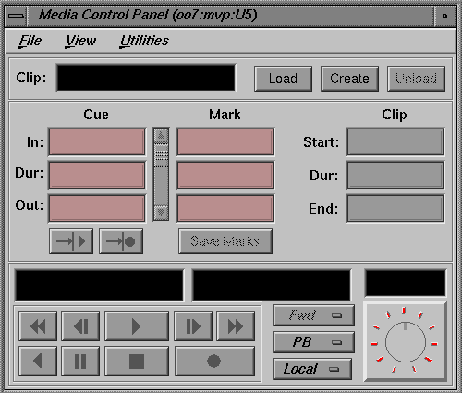
- When mcpanel is started a connection can be made to a media port or to a existing unit

/usr/vtr/bin/mcpanel hostname videoPort|unit

- mcpanel has the following start options

/usr/vtr/bin/mcpanel [-h hostname][-p videoPort|unit]

[-c clipname]
[-r]
[-C "inpoint outpoint"]
[-P]
[-v loglevel
[-D deckCtlPort]

-c Identifies the name of a clip to be loaded when the Media
Control Panel starts. If this option is not specified, no clip is initially loaded.

-D Specifies the video deck control port (deckCtlPort) to be used
for V-LAN communication to an external video storage device, such as a digital videotape recorder (VTR). The deck
is controlled by the Deck Control Panel. If this option is not specified, deck control is not available

-h Identifies the host on which VCP-Recorder runs. This enables the Media Control Panel to be run from a remote
workstation. If this option is not specified, the local host is assumed

-p Identifies the VCP-Recorder host video port or unit to which
he control connectio is made (check with vtrstat –p)

-r Specifies that if an mcpanel already exists for the video port, the existing mcpanel should be raised on the desktop instead of creating a new one

-C Specifies that the loaded clip should be cued with the specified in- and out-points If “*” is specified for either inpoint or outpoint, the default edit in-point or out-point is used

-P Specifies that the clip whose name is clipname should start
playing when the Media Control Panel starts

-v Sets the logging verbosity level to loglevel

- mcpanel can be started from any workstation and connect to any networked VST server using the
–h hostname option

- When mcpanel is started on the local VST server, the default behaviour is that there will be unit created on the media port with the lowest logical number

vtrstat -p
# Port Type Description
----------------------------------------------------------
1 DIVO_DVC_0 Video SGI Digital Video Option (DVC)
2 DIVO_DVC_1 Video SGI Digital Video Option (DVC)

In this example that will be DIVO_DVC_0

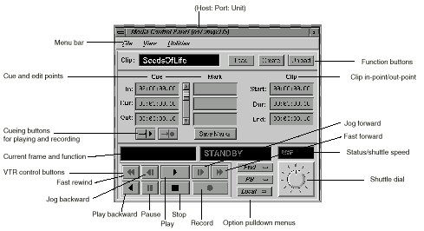

- The options of the direction selector

Fwd for forward play (default)
F Lp for forward loop play
Bwd for backward play
BLp for backward loop play
F/Bwd for alternating forward and backward play
F/B Lp for alternating forward and backward loop play
B/Fwd for alternating backward and forward play
B/F Lp for alternating backward and forward loop play

- The playbackmode options are

PB the clip’s audio and video are output when a clip is
playing; nothing is output at other times (default)
PB/EE the clip’s audio and video are output when a clip is
playing; the input signal is output at other times

Note: The EE (end-to-end) option emulates a video deck feature
and is relevant only when you have an active input source

PB/Im the clip’s audio and video are output when a clip is playing; SMPTE 75% colors bars and 1 kHz tone are output at other times
PB/B the clip’s audio and video are output when a clip is
playing; a black screen is output at other times
EE the output always displays the input signal instead of
the signal from VST, even when a clip is playing
(When a clip is playing, the output displays the input signal)
Image the output always displays SMPTE 75% colors bars and plays a 1 kHz tone
Black the output always displays a black screen
Hold the output always displays the last image
- Procedure for playing out clips

connect a mcpanel to the desired media port or unit
load the clip
determine the direction
cue the clip
play the clip

- When recording clips make sure to select the right format and compression

- Start the Deck Control window from the mcpanel
connected to the media port which is connected to the VTR

- When the V-LAN or the diaquest media port module
is installed the remote VTR can be controlled via the
the deck control GUI.

- See Developers Guide for details how to use this option

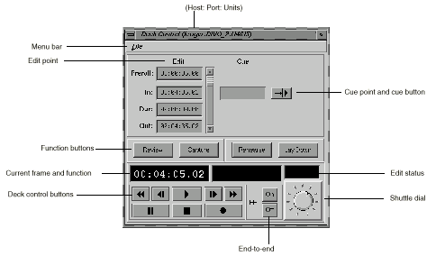

mcclips

- mcclips is the VST clip mager with basic file management fuctions as

renaming
deleting
setting the protections
archive interoperability

- Like the other GUI’s a remote VST server can be managed by using the –h hostname option

/usr/vtr/bin/mcclips [-v loglevel][hostname]
