



\
High performance solutions:
FIRE on DIGITAL platforms
The fluid mechanics tool for accurate and cost effective simulations

Founded in 1948, AVL is the world’s largest privately owned and independent company for engine engineering and instrumentation. DIGITAL is a recognized leader of high performance computing with over 40 years of engineering innovation. In a successful partnership, DIGITAL and AVL collaborate to bring you FIRE, a fluid mechanics simulation tool running on DIGITAL’s high performance computer systems.
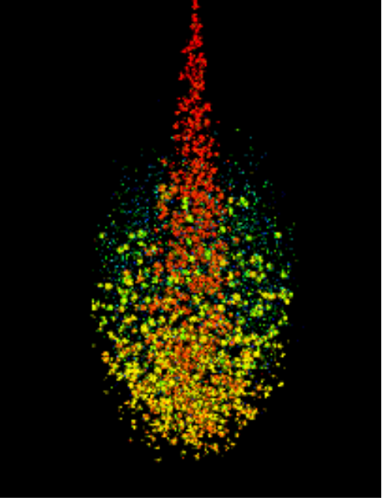
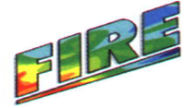
Droplet distribution −- Simulation of a diesel spray in a pressure chamber at 20 bar gas pressure

Analysis of mixture formation in internal combustion engines can be simulated by state-of-the-art physical models and high performance computer systems.

FIRE highlights

Accurate simulation of the formation and propagation of fuel sprays is one of the milestones which have to be met in the process of successful simulation of the complete working cycle of an internal combustion engine.

AVL has developed the fluid mechanics software package FIRE, which is now in use within the automotive industry to simulate fluid flow and combustion in engines.

To address the problem of mixture formation in diesel and gasoline engines, FIRE includes a spray module to

DIGITAL engineering solutions are setting a new standard in performance and quality. Combining optimized software packages from the leading Application Partners in the engineering industry with the latest high performance computing technologies, DIGITAL is moving rapidly to provide you with the most advanced solutions to engineering problems.

The DIGITAL advantage

The fastest microprocessor in the industry for unmatched application performance

Advanced 64-bit computing for handling the largest, most complex problems

FIRE highlights, continued
simulate two-phase flows, consisting of a continuous phase laden with particles or liquid droplets. Similarly the capability to calculate particle and droplet laden flow is widely used in chemical engineering, food processing and the analysis of sedimentation problems.
Accuracy and performance
Simulation of the mixture formation processes are only of interest to design engineers if the accuracy meets certain requirements. This defines the necessary complexity of the used physical models and the size of the models representing the complex geometrical conditions existing in engines.

Today, the powerful DIGITAL 8000 series running with a performance in the range from 100 MFLOP/s to 0.5 GLOP/s for FIRE applications allows the analysis of problems of this kind in a practical time scale.
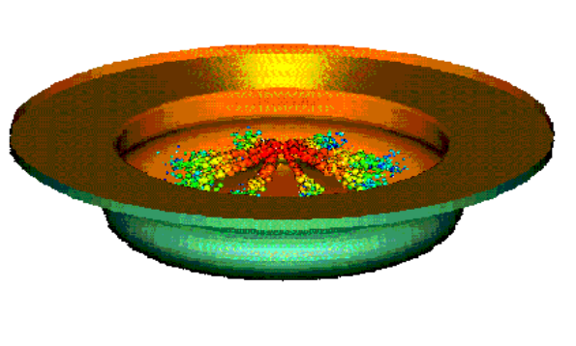
Simulation of a diesel spray in the combustion chamber of a high speed DI engine.

The DIGITAL advantage, continued
DIGITAL’s TruCluster technology with high-bandwidth, low-latency Memory Channel enables supercomputer-class performance at a fraction of the cost of traditional supercomputers
Choice of Alpha and Intel processors, UNIX and
Windows NT operating systems for flexible deployment
options
PowerStorm graphics, the best price-performance graphics available, to speed your pre-and post-processing tasks
Leadership GIGAswitch and MultiSwitch 900 network
Backbones for the ultimate throughput in high performance networked computing

High performance, high capacity StorageWorks products to
archive large volumes of data

The scalability and continuing evolution of the Alpha architecture ensures the growth you need to protect and enhance your investment

Unmatched systems support and integration services ensure the highest availability and the most efficient use of your equipment

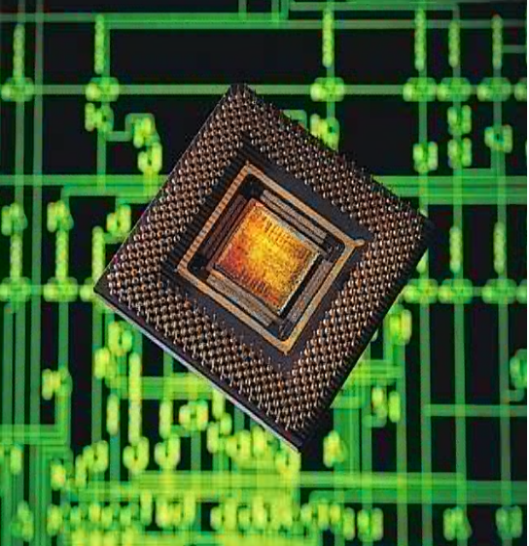

Design for manufacturability.
Shorten time to market.
Get it right the first time.

Think DIGITAL and FIRE.


Digital Equipment Corporation www.digital.com
AVL Corporation www.avl.com

DIGITAL believes the information in this publication is accurate as of its publication date. Such information is subject to change without notice. DIGITAL is not responsible for any errors in the information given in this publication. DIGITAL, the DIGITAL logo, TruCluster, GIGAswitch, StorageWorks, PowerStorm, and Alpha are trademarks of Digital Equipment Corporation. AVL and FIRE are registered trademarks of AVL Corporation. Memory Channel is a trademark of Encore Computer Corporation. Intel is a registered trademark of Intel Corporation. Microsoft is a registered trademark, and Windows NT is a trademark of Microsoft Corporation. UNIX is a registered trademark of X/Open Company Ltd. All other marks are the property of their respective holders.

